Additional Receipt Reference Columns - C0437

|  |  |  |  |  |
| --- | --- | --- | --- | --- |
| **Ver** | **Date** | **Author** | **Comments** | **Reviewed by** |
| 1 | 03/02/2020 | Tom Bell | CRIM 0437 | TBC |
|  |  |  |  |  |

Requirements 2

Prerequisites 2

Solution Overview 2

Solution Details 2

Security 3

Companies 3

Data Migration 3

Test Steps 3

Technical Implementation 3

Requirements

In the Manual Supplier Invoice screen (EE) and New Manual Supplier Invoice Screen (Aurena), clicking into the list of values on the “Receipt Reference” field. The list screen requires additional columns in both Aurena and EE.

Prerequisites

<Describe any pre-requisites that this development may rely upon, data configuration or other developments>

Solution Overview

Within the New Manual Supplier Invoice screen (Aurena) and the Manual Supplier Invoice Screen (EE), when opening the list of values for the Receipt Reference field, there needs to be additional columns in the list screen.

# Aurena – Receipt Column Location

The below screenshot shows the Receipt Reference list of values buttons in the New Manual Supplier Invoice screen. By clicking onto this button, the user is brought to the second screenshot.

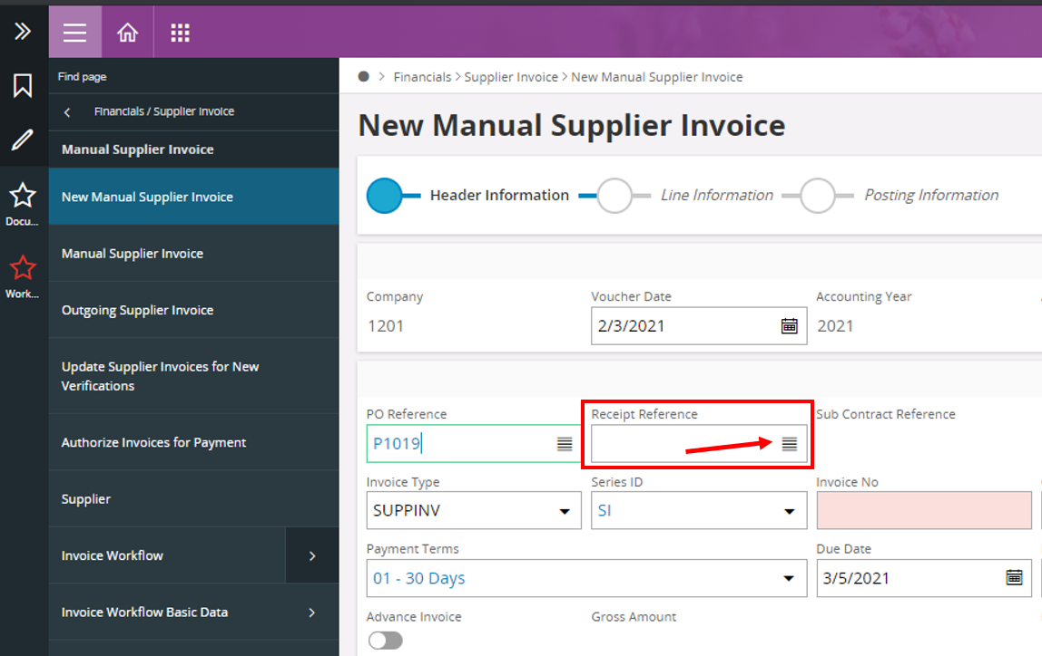

The below screenshot shows the Receipt Reference list screen. It is in this screen where the additional columns must be located in IFS Aurena.

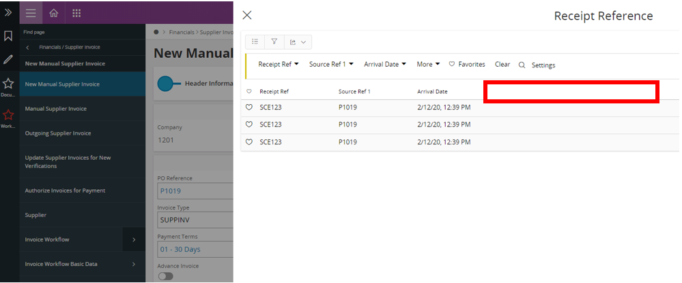

# Receipt Columns Location in EE

The below screenshot shows the Manual Supplier Invoice screen and the Receipt Ref. field. Selecting this field and opening the “list of values” should bring the user to the screen in the below screenshot

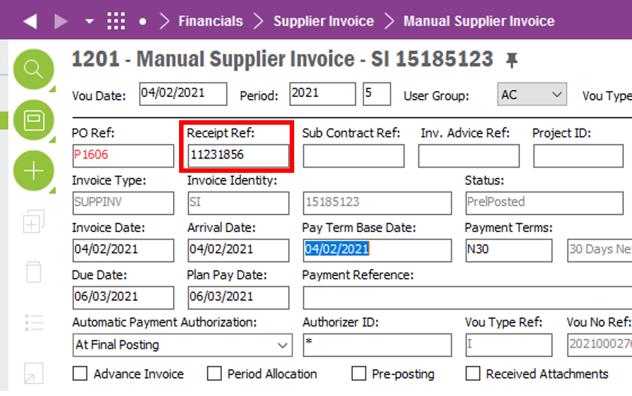

The below screenshot shows the list of values screens of the Receipt Ref field in EE. The red box in the dialogue box is where the columns should be located.

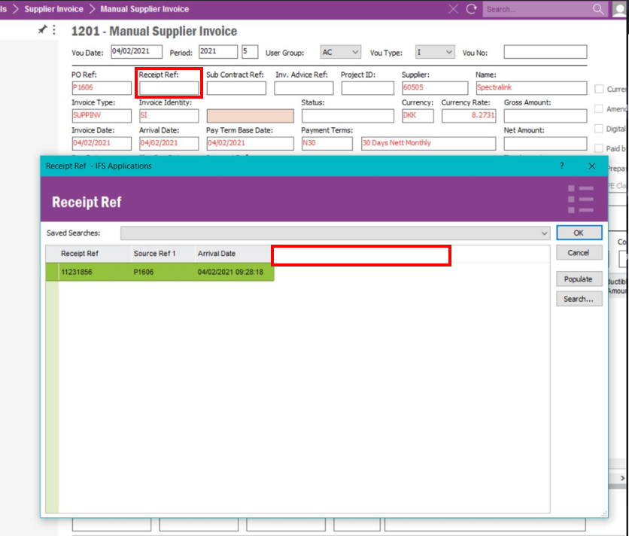

# Additional Column Names

* Part Number
* Part Description
* Invoiced Quantity
* Arrived Quantity
* Order Quantity
* Remining Quantity to be Invoiced.

Solution Details

The below section will cover the columns that are required and where the data can be obtained from in the system.

# Part Number Column

A column called “Part Number” is required that shows the Part Number for corresponding PO Number (Source Ref 1) and Receipt Reference (both shown in blue on the screenshot). The Part Number field is shown in red below.

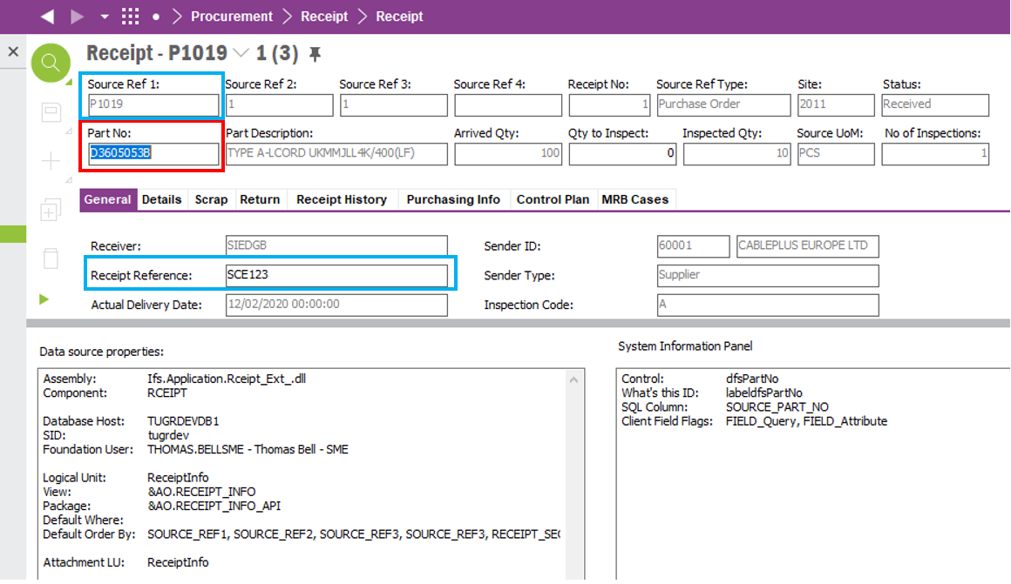

# Part Description Column

A column called “Part Description” is required that shows the Part Description for the corresponding PO Number (Source Ref 1) and Receipt Reference field (both shown in blue on the screenshot). This field NOT depend on the Part No. field as there will be PO’s with No Parts attached and therefore only have a Part Description. The Part Description field is shown in red below.

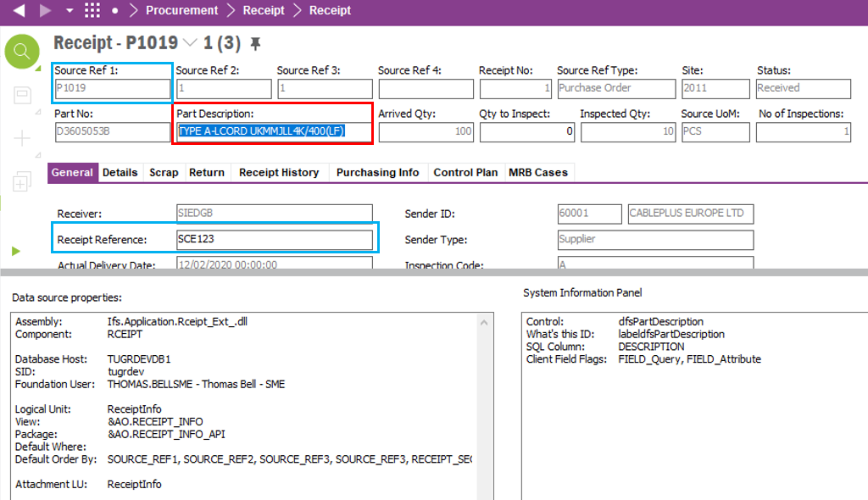

# Invoiced Quantity Column

A column called “Invoiced Quantity” is required that shows the Invoiced Quantity for the corresponding PO Number (Source Ref 1) (shown in blue on the screenshot) and the Receipt Reference (see General tab in Receipt screen). The Invoiced Quantity field is shown in red below.

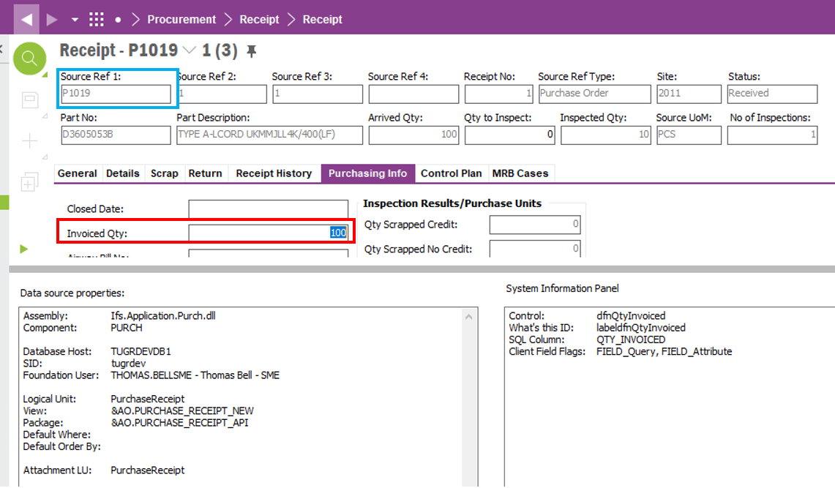

# Arrived Quantity Column

A column called “Arrived Quantity” is required that shows the Arrived Quantity for the corresponding PO Number (Source Ref 1) and the Receipt Reference (both shown in blue on the screenshot). The Arrived Quantity field is shown in red below.

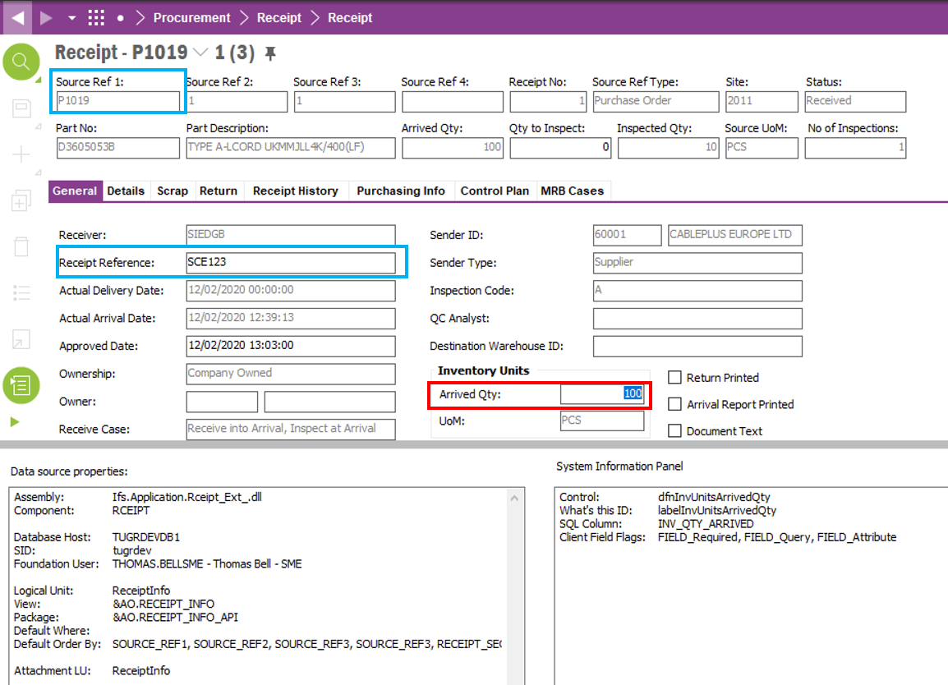

# Order Quantity Column

A column called “Order Quantity” is required that shows the Order Quantity for the corresponding Part Description on that Purchase Order (both fields shown in blue on the screenshot). The Order Quantity field is shown in red below.

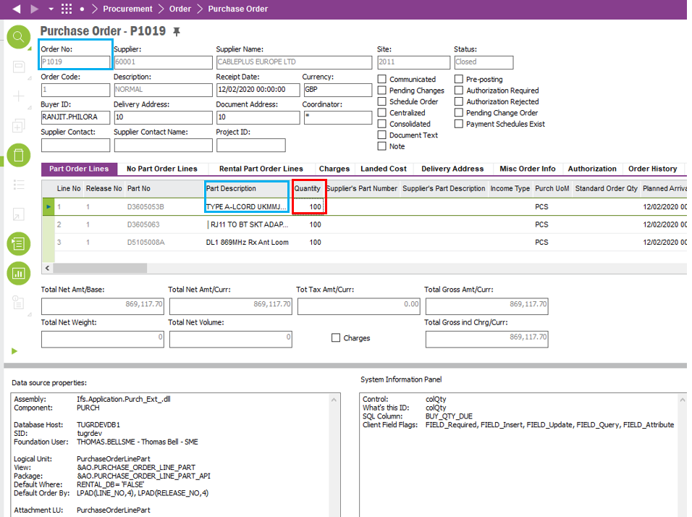

# Remaining Quantity to be Invoiced.

A calculated column is required that is called “Remaining Quantity to be Invoiced. The data in the field must be for the corresponding Part Description on the Purchase Order

The calculation is as follows:

***(Invoice Quantity Arrived – Invoiced Quantity)***

Invoice Quantity Arrivedamount can be found here.

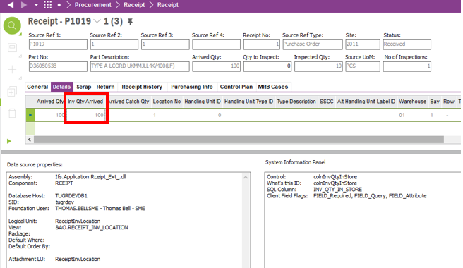

Invoiced Quantity amount can be found below, see red box below.



**Technical.**

Field Definitions.

<New Field/CLU Definition>

|  |  |  |  |  |  |  |
| --- | --- | --- | --- | --- | --- | --- |
| New DB Object Name | DB Object Item/Field Names | Item Description | Item Data Type | Item Syntax | Calculation Spec, if Derived | LOVs/Enums/Is Mandatory? |
|  |  |  |  |  |  |  |
|  |  |  |  |  |  |  |
|  |  |  |  |  |  |  |
|  |  |  |  |  |  |  |
|  |  |  |  |  |  |  |
|  |  |  |  |  |  |  |
|  |  |  |  |  |  |  |
|  |  |  |  |  |  |  |
|  |  |  |  |  |  |  |
|  |  |  |  |  |  |  |
|  |  |  |  |  |  |  |
|  |  |  |  |  |  |  |

Security

<Define security controls> (Who needs access to this and will it be restricted from any other users etc)

Companies

Applies to the following companies. All.

|  |  |
| --- | --- |
| **Company** | **Required (Y/N)** |
| 1201 | Y |
| TBC |  |
|  |  |

Data Migration

<Describe any data migration impacts this development may have – i.e additional data to be migrated>

Test Steps

<Steps that needs to be taken to test this change. Please provide expected results> Updated post solution.

|  |  |  |
| --- | --- | --- |
| **No** | **Script\Test Steps** | **Expected Result** |
| 1 | When creating a New Manual Supplier Invoice in Aurena or EE. | Click into list of values in the Receipt Reference and see the additional columns with the correct data. |

Technical Implementation

<Completed by the technical developer - Technical solution, list packages, functions, Custom menus created etc >

Originally, additional columns cannot be connected to the Receipt Ref LOV as the OBJKEY was not available. However, the RnD (Standard functionality) view receipt_reference is now overridden to have OBJKEY and a few other columns with L flag false.

Note: - With this correction, the customer will have to deploy a post installation sql script after every build/upgrade to make sure the view is not overridden again by the RnD corrections. Please see the attached Receipt_Ref.sql.



Delivery Notes

* Package – EA_FINANCE
* Permissions granted – IFS_ALL
* Deployment Steps

1. Deploy the attached SQL Script in the database.
2. Refresh reference cache from the application.

1. Make sure the **objkey** **available** column is ticked as shown below.

1. When the Logical Unit is published and synchronized, make sure the following view is also approved, published, and synchronized.

**Custom Fields**

1. To enable the Custom Fields in the LOV, reload configurations in the Receipts Page.
2. RMB on the column of the Receipt Reference LOV in the Manual Supplier Invoice window, Properties, Table Tab, Choose the required columns.

**Aurea Configuration**

In Aurena, Go to New Manual Supplier Invoice, Page Designer,

Click on the ManSuppInvoiceGroup, expand the content, Receipt Reference, LOV, click on the advanced view

Check if the custom fields are added as shown below,

